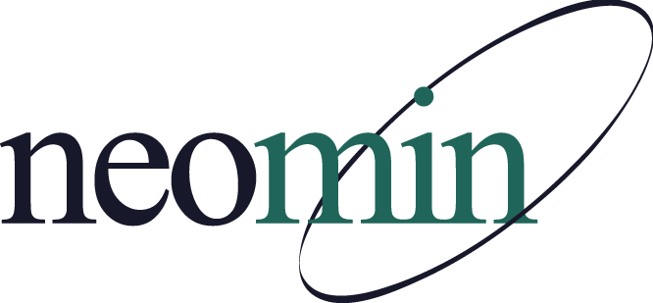

NEOMIN Library Services
Library User Group Meeting
Thursday, March 26, 2015 at 1:00 PM
NEOMIN Training Lab

Agenda

Welcome – Autumn Roper, NEOMIN

- Meeting resources & links: https://www.smore.com/kpqat

Open Discussion
- Feedback requested - How are Trumbull County Library Media Specialists evaluated?
- February's Kapco Workshop feedback
- Next Meeting: April 23, 2015 - Presenter is Andria Morningstar-Gray, LAKHS

NEOMIN Spring Trainings
- April 21, 2015 - Statistic & Collection Analysis (AM & PM)
- May 14, 2015 - Library Inventory Process (AM & PM)

INFOhio District/Building ICoach Program FY16
- 153 ICoaches now (renew mid-March)
- March 5- April 15 (Applications available)
- Training - via Blackboard (May-Aug)
- Librarians, aides, teachers, principals

INFOhio Tech Skills for Online Testing Pearltree - Whitelist
- The purpose of this list is to help technology coordinators, library media specialists and teachers to know the direct URL for the web-based resources to be able to include on the whitelist for school filtering software.

OhioNET Member Library Discounts
- Discount on equipment, supplies, and databases
- Toolkit page, flyer section (forward to Librarians & Treasurers)
- Did anyone participate in the free trials (Feb 1 - Feb 27)?

Need to Purchase a New Barcode Scanner?
- Discounts through RACO Industries
- Contact: Lisa Kramer, 1-800-446-1991 x2549

NEW INFOhio Handbook Video Tutorials
- 15 videos were made available from Karen Coy (retired ITC support person)

Storia: Pilot Year Statistics
- 50% of 4th grade classrooms in Ohio have signed-up
- 2,600+: Teacher Access Codes distributed
- INFOhio working on securing availability for next year

World Book: New Interfaces!
- World Book Kids (Released Feb 20)
- World Book Student & Advanced (new interface scheduled for release Mar 20) -- NOT simultaneous access to both current and new interfaces. INFOhio may wait until summer to implement.

World Book Kids
- Device agnostic
- Predictive search
- Explore (formerly Article Browse)
- Feature container (hide/show)
- New article layout -- splash imagery on left, tabs across top (Article, "Pictures, Videos, and More", More information, Contents, Tools)
- Feature Container -- Activities ("For Grownups" includes lesson plans), Games (50+ games corresponding to curricular subjects. Sorting, matching, crosswords, multiple choice, puzzles), Compare Places, Science Projects (20+)
- For Educators >> Educator Tools (Curriculum Correlations, Lesson Plans)

EBSCO: NEW Explora Interface
- Searchasaurus, KidsSearch, and Student Resource Center replaced by "Explora" (End-of-life, June 30th, 2015)
- Secondary Explora looks a lot like "Points of View Reference Center" by EBSCO
- INFOhio to determine best options / features / databases for various audiences
- INFOhio will make the interface available to Providers and ICoaches, and then to users

Compulsory Return Dates
- Verify 2015-16 dates
- Complete survey to submit 2017-18 dates

New NEOMIN Helpdesk
- NEOMIN is implementing a new helpdesk system called Cherwell Service Management.
- Student Service volunteers are testing the functionality of the helpdesk portal. (Technology Coordinators were also shown the new system.)
- The attendees of this meeting will be shown how to log into the new helpdesk portal.
- Full implementation to all NEOMIN users – Fall 2015.
Adjourn

- Next meeting: April 23, 2015 at 1:00 PM

