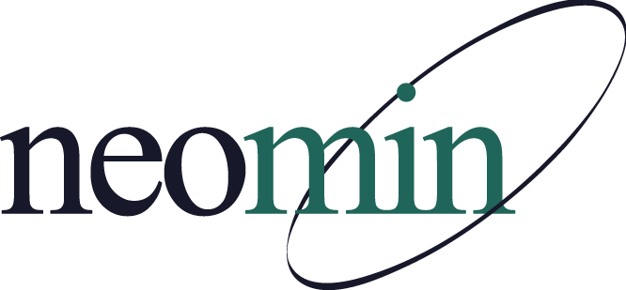

NEOMIN Library Services
Library User Group Meeting
Tuesday, December 15, 2015 at 1:00 PM
NEOMIN Training Lab

Agenda

Guest Speaker: Jennifer Schwelik, eLearning Specialist, INFOhio

Annual Library Reports – Session 1: Sharing Resources

Open Discussion

Adjourn
- Next meeting: Tuesday, January 12, 2016 at 1:00 PM

